**Images and Alt text:** 35 <https://drive.google.com/drive/u/0/folders/1te2jy6VI52mnbWVwB3XFlho-LBkq8yBq>

**Slug: linkedin-post-ideas**

**Internal link:** 6

**External link: 4**

Meta: 35 LinkedIn post ideas for your brand! From sharing progress to expert tips, use these strategies to drive engagement. Plus a tool to convert views into customers.

# LinkedIn Creator Playbook: 35 LinkedIn Post Ideas that will drive inbound B2B leads

This article is for you if…

* You’ve been seeing more and more **B2B business owners** build a brand and **grow their business on LinkedIn** ([a sales trainer friend of mine](https://www.linkedin.com/in/jeremyleeminer/) does, and he gets most of his new clients from LinkedIn now)
* You’re looking for ways to [make your own content](https://www.salesrobot.co/free-tools/linkedin-post-generator) stand out and drive real results.

I hear you.

LinkedIn is winning right now for getting clients because it’s a great platform to build your brand.

It’s the **only B2B platform**.  
  
- **Tiktok/Instagram are *too* consumer-focused**.  
- **Facebook has been dead** for a while (well, ***except*** Facebook groups, which still works)

And, LinkedIn is not too crowded (yet). So you need to get in before it does.

That’s why [LinkedIn](https://www.linkedin.com/) is leading the charge.

Professionals with real-world experience are sharing their insights, adding their own spin on topics—and it’s paying off.

They’re growing their follower counts, increasing profile views, and generating more leads.

Want in on the action?

In this article, I’ll share 35 LinkedIn post ideas you can use right now to start creating engaging, impactful content while still showing off your personality.

Let’s get started!

<https://www.youtube.com/watch?v=v1iktUYxW7w>

## Why Should You Post on LinkedIn?

There’s 3 reasons why everyone should be posting on LinkedIn:

**1. Increase Brand Awareness**

Posting consistently on [LinkedIn boosts your brand’s visibility](https://www.forbes.com/sites/renaegregoire/2024/05/01/5-tips-for-using-linkedin-to-build-your-personal-and-company-brand/).

If your content has unique value and quickly creates engagements, the platform’s targeting ensures it **reaches the right audience**, leading to more followers and engagement.

**2. Expand Your Network**

With over 1 billion members, LinkedIn provides a huge opportunity to connect with industry peers, potential customers, employees, and partners.

You never know who might see your content, become your [1st-degree connection](https://www.salesrobot.co/blogs/linkedin-degree-of-connection-what-do-1st-2nd-and-3rd-mean), **and ultimately, your customer**.

**3. Build Trust**

Sharing valuable, authentic content regularly helps establish trust with your audience, making them more likely to do business with you or recommend your brand.

<https://www.youtube.com/watch?v=ObPHF7-4Kyo>

So, without wasting your time, let's get into the content ideas.

## 35 LinkedIn Post Ideas You Should Share

These LinkedIn post ideas are pulled straight from the content playbooks of top LinkedIn creators, and we have included examples as well.

That way, you’ll have tons of inspiration to craft content that truly connects with your audience and gets results!

1. **Before and After**

Show progress by comparing where you started and where you are now.

You can share specific milestones, challenges you overcame, and lessons learned.

This makes you relatable and inspires your audience.

If possible, add visuals to make the transformation more tangible and impactful.

Graphics provide a quick and easy way to understand something, much better than just text.

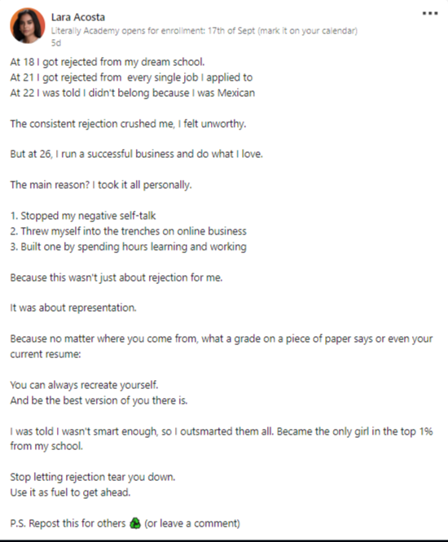

1. **Tell your origin story**

Share the journey that led you to where you are today, and focus on the key moments.

You need to **be authentic**— it helps you create a deeper connection with your audience, showing them the human side of your success.

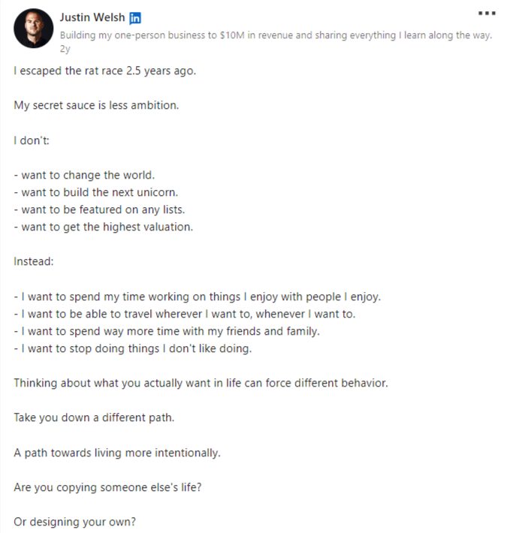

1. **Challenges to Overcome**

Talk about obstacles you’ve faced and how you conquered them.

You can share strategies that helped you. This would be a valuable lesson for your audience.

You need to be vulnerable on LinkedIn because that makes your story relatable.

Here’s a template you can start with:  
  
  
If you’re not {action}, you’re falling behind.

But getting started isn’t easy.

99% are doing it wrong.

But you’re in the top 1%…

Right?

So…

Avoid these beginner {topic} mistakes at all costs:

1. {Common mistake, described in 8 words}

2. {Common mistake, described in 8 words}

3. {Common mistake, described in 8 words}

4. {Common mistake, described in 8 words}

5. {Common mistake, described in 8 words}

Instead, focus on:

1. {Solution, described in 6 words}

2. {Solution, described in 6 words}

3. {Solution, described in 6 words}

4. {Solution, described in 6 words}

5. {Solution, described in 6 words}

And remember:

{Positive advice, described in 6 words}

{End}.

1. **Books for Transformation**

Recommend books that have significantly impacted your growth.

You can make it actionable by explaining one key takeaway from each book and how readers can apply it to their own lives.

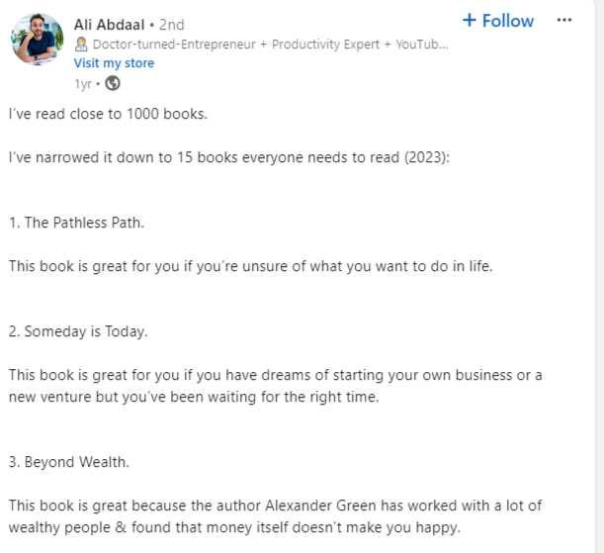

1. **Tools to Try**  
     
   Suggest helpful tools that can improve productivity or solve problems.

You must also share the workflow you used to save time or overcome any common challenges.   
  
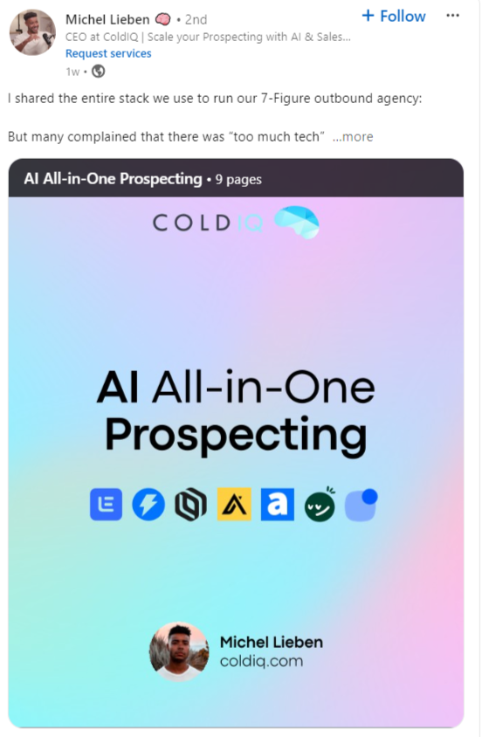

1. **Highlight of the week**

Share your biggest win or a noteworthy moment from the past week.

Whether it's your personal achievement, a professional milestone, or an unexpected breakthrough, mention what its impact was and the lessons you learned.

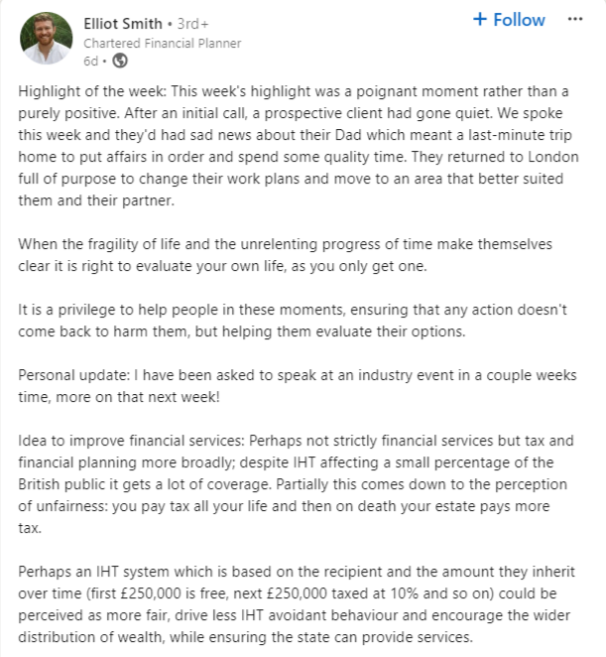

1. **Mental Mindset Transformation**  
     
   Discuss a mindset shift that helped you grow or succeed.  
     
   You can share how changing your perspective opened up new opportunities or helped overcome setbacks.  
     
   Here’s a template to try:

{Strong belief or stance about topic}.

My {topic} process from start to finish in 11 stages:

1. {Step 1 succinctly described in 4 words or less}

2. {Step 2 succinctly described in 4 words or less}

3. {Step 3 succinctly described in 4 words or less}

4. {Step 4 succinctly described in 4 words or less}

5. {Step 5 succinctly described in 4 words or less}

6. {Step 6 succinctly described in 4 words or less}

7. {Step 7 succinctly described in 4 words or less}

8. {Step 8 succinctly described in 4 words or less}

9. {Step 9 succinctly described in 4 words or less}

10. {Step 10 succinctly described in 4 words or less}

11. {Step 11 succinctly described in 4 words or less}

That's my process.

What's yours?

1. **Personal or Professional growth**

Reflect on your personal or Professional development over a set period.  
  
You can highlight key areas where you’ve evolved, such as new skills acquired, habits formed, or challenges overcome.  
  
Here’s a template:

I've made every mistake in the {topic} book over the last five years.

From {beginners mistake}...

To {beginners mistake}…

All the mistakes have taught me how to do it right.

Here are the top 3 [topic} essentials to help you stand out:

1. {Essential element 1, explained in 6 words}

2. {Essential element 2, explained in 6 words}

3. {Essential element 3, explained in 6 words}

Combine these with:

- {Action 1, explained in 6 words}

- {Action 2, explained in 6 words}

- {Action 3, explained in 6 words}

And you’re on the right track.

This game isn't rocket science.

It just takes elbow grease.

Put the hours in...

And you'll {outcome} sooner than you think.

1. **One-Liners to Add**

Share short, impactful statements that inspire or motivate.

Here’s how I do it:   
  
First, create a list of my favorite quotes that resonate with my values and goals. Then, explain why each statement is meaningful to me.   
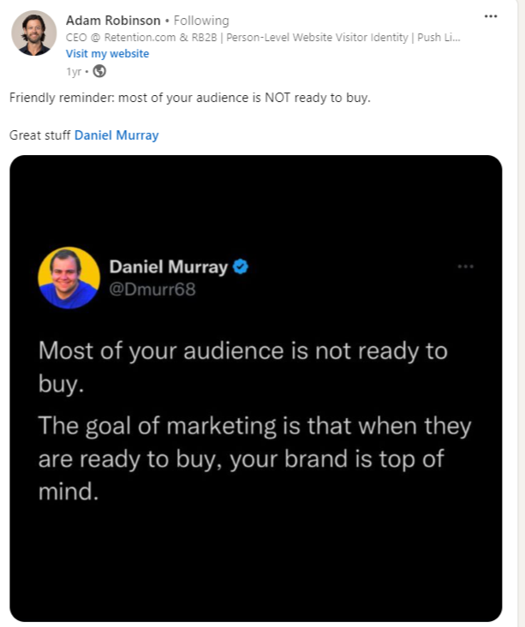

1. **Podcast Interview**  
     
   Share insights or lessons learned from a recent podcast appearance or listen.

And If you were the guest, discuss the experience and any surprising questions or feedback you received

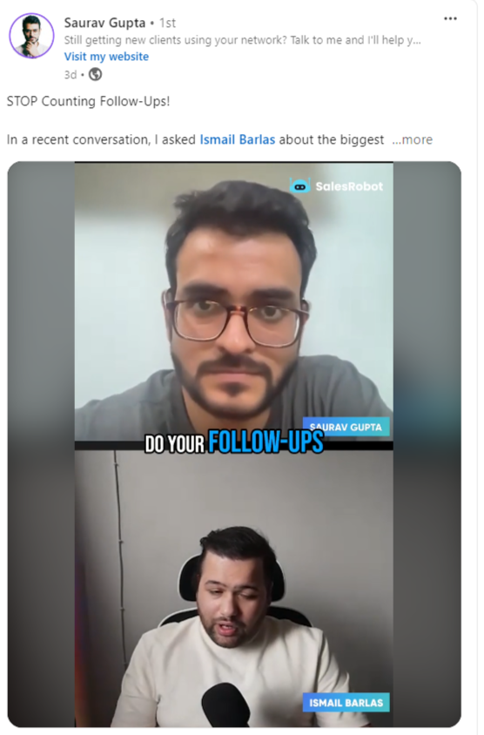

1. **Happiness & Positivity Quotes**

Post an uplifting quote that resonates with your values.

You can add a personal anecdote that connects the quote to your experiences, make it even more relatable and impactful.  
  


1. **Encouragement and Support Quotes**  
     
   Offer words of encouragement that inspire you during tough times.   
     
   You can also Invite your audience to share their own favorite quotes.

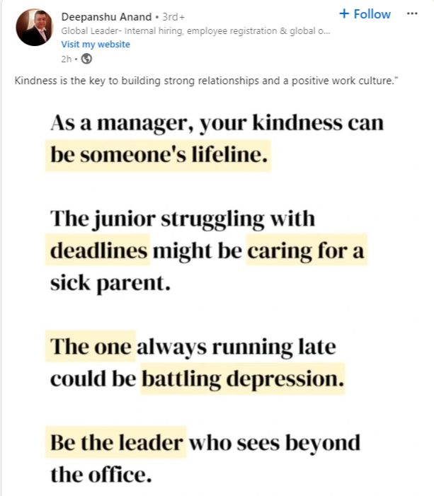

1. **Build in public**  
     
   Share your progress and learnings as you develop a product or service in real-time.   
     
   My advice is that you be transparent about your decision-making process.

This openness builds trust with your audience and invites them to engage, provide feedback, and learn alongside you.  
  
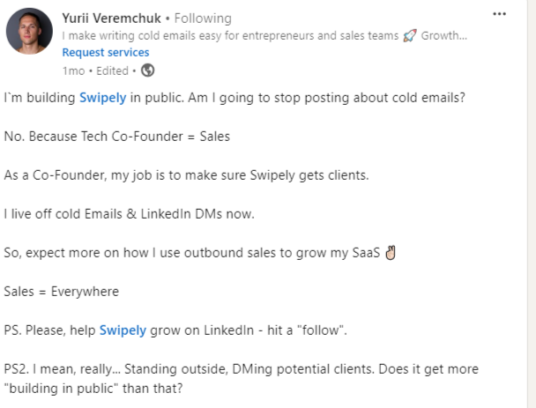

1. **Share jobs and other professional resources**  
     
   Help your network by posting job opportunities or useful career resources.

Additionally, you can share a list of resources—such as workshops, courses, or networking events—that can help others.

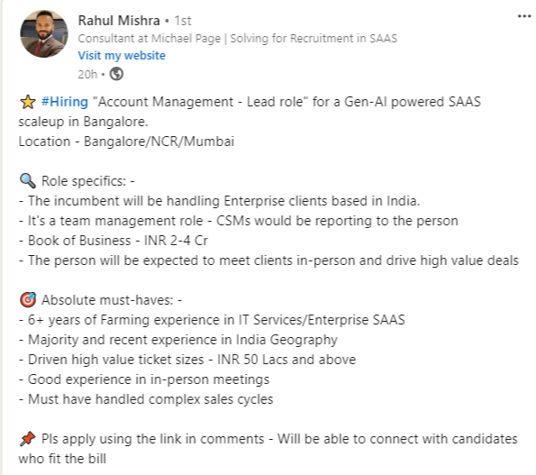

1. **Create a carousel of evidence-backed tips**

Present useful, research-based tips in a visually engaging carousel format.

This is an interactive approach that not only educates but also fosters a sense of community among your followers.

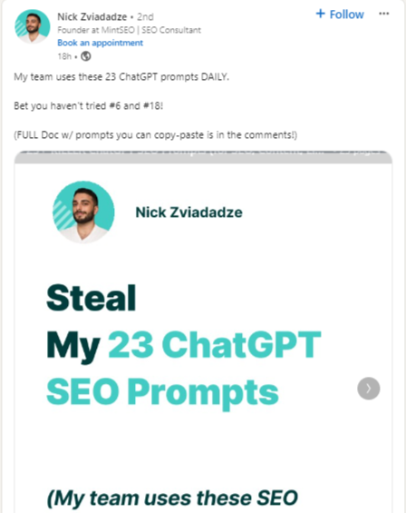

1. **Build anticipation for a launch**  
     
   Tease an upcoming product, service, or event to generate buzz.  
     
   Share sneak peeks, behind-the-scenes content, or cryptic hints that spark curiosity.

Keep your audience guessing.   
  
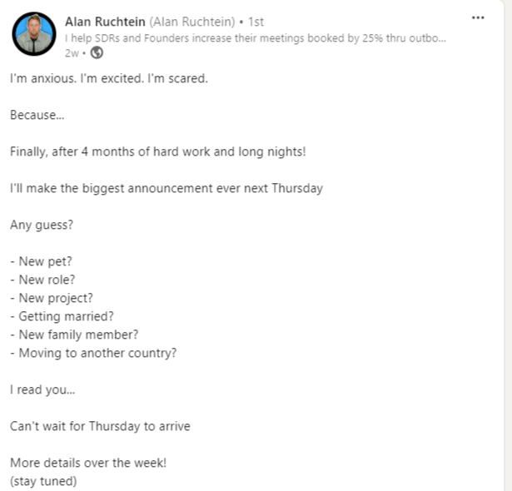

1. **Start a weekly series**  
     
   Commit to posting on a specific topic every week to build consistency and engagement.

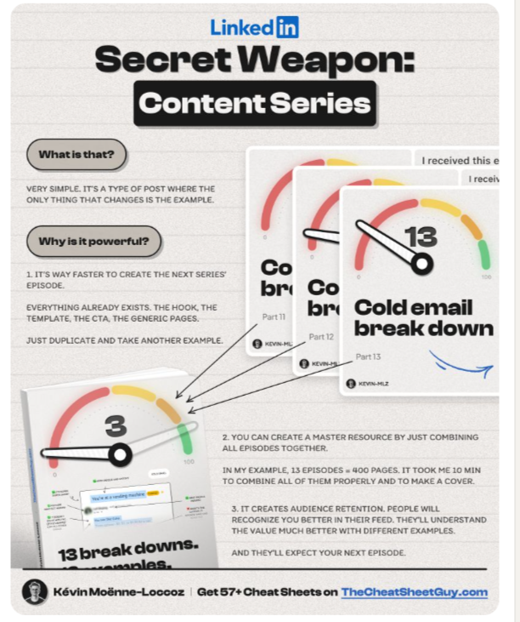

1. **Use video to explain a complex topic**  
     
   Simplify a challenging subject with **a video breakdown.**

Keep your videos concise and focused, breaking down the information into digestible segments.  
  
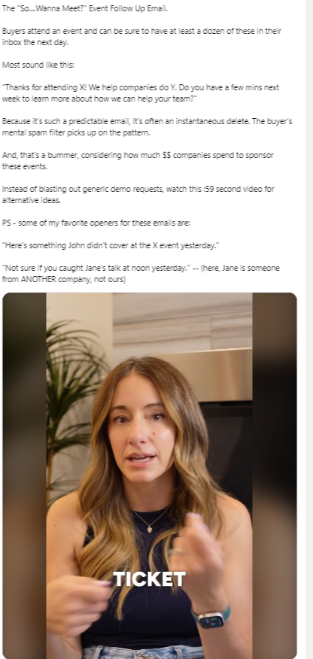

1. **Share advice on what NOT to do**  
     
   Offer guidance by explaining common mistakes to avoid your industry or area of expertise.  
     
   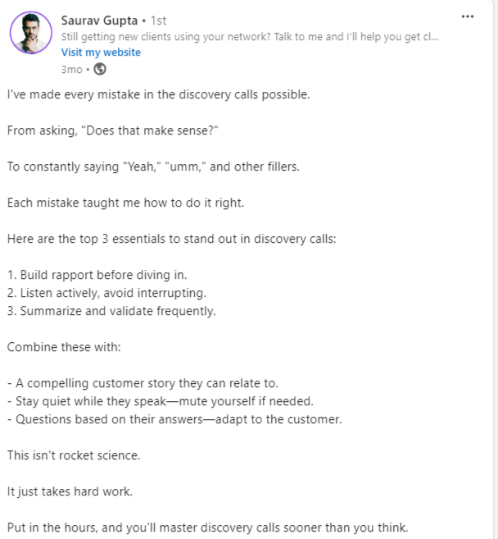
2. **Break down your workflow**  
     
   Walk through your process or workflow step-by-step.   
     
   Use visuals or infographics to illustrate each stage, making it easy for your audience to follow along.  
     
   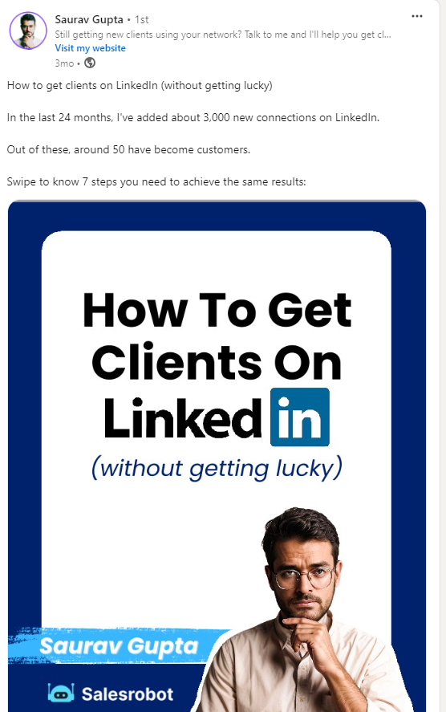
3. **Run a poll (and use the responses as data)**  
     
   Ask your audience a question in a poll to see what they think about something important.

Let them vote and share their choices. After everyone has voted, look at the answers and tell your audience what you found out. **Share interesting results or surprises.**  
This helps your audience feel involved and shows that their opinions are important to you.  
  
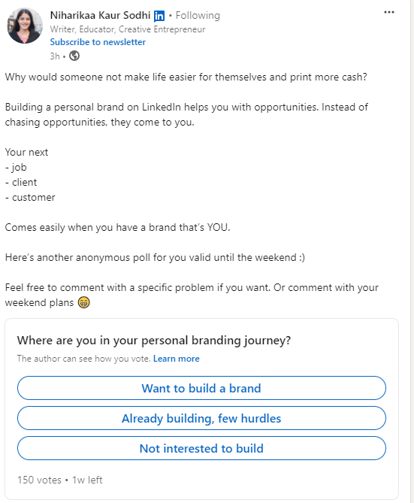

1. **Use a well-known meme format to tell an industry inside joke**  
     
   Leverage humor with an industry-specific meme that your audience will relate to.   
     
   This approach entertains and fosters a sense of community among professionals who share similar experiences and challenges.   
     
   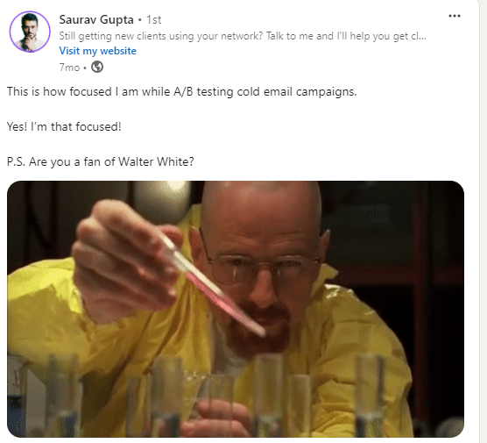
2. **Show off your expertise in a beginner's how-to**  
     
   Provide a simple, beginner-friendly tutorial in your area of expertise.

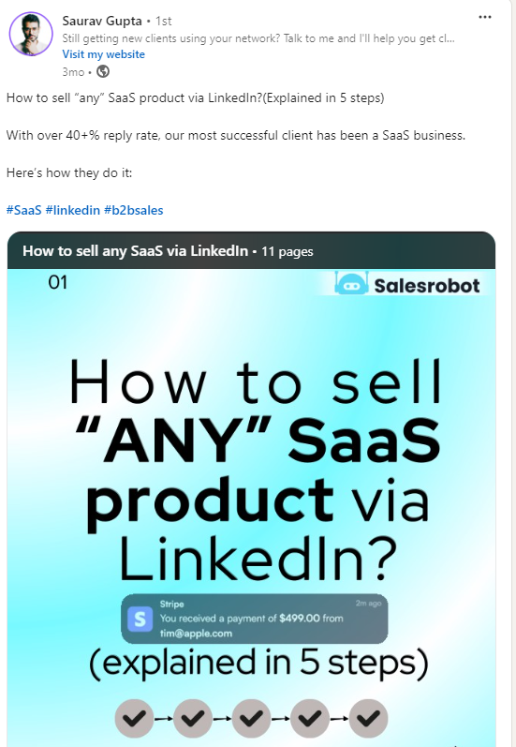

1. **Summarize your best case study**  
     
   Highlight a successful project or case study with key takeaways.

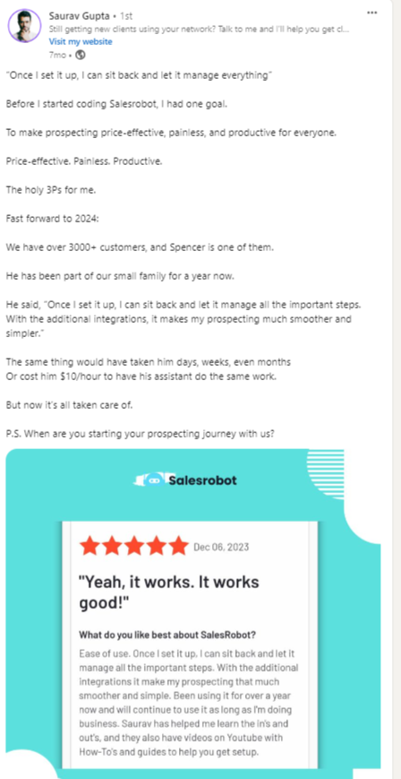

1. **Turn research into mini reports**  
     
   Share bite-sized insights from in-depth research in a digestible format. Present findings in a visually appealing way - infographics, carousels, or short video.

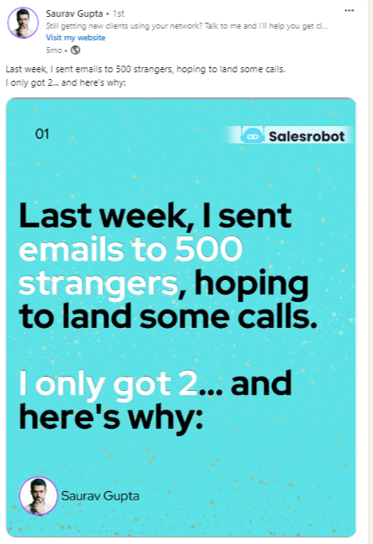

1. **Free Resources**  
     
   Offer free tools, guides, or templates that add value to your network.  
     
   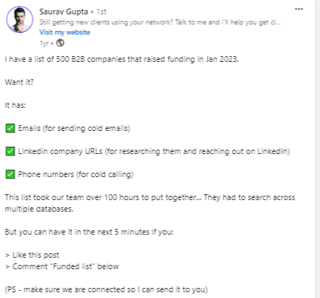
2. **Checklists**  
     
   Provide a practical checklist that helps your audience stay organized or achieve a goal.   
     
   Consider including tips or best practices alongside each checklist item to add extra value.  
     
   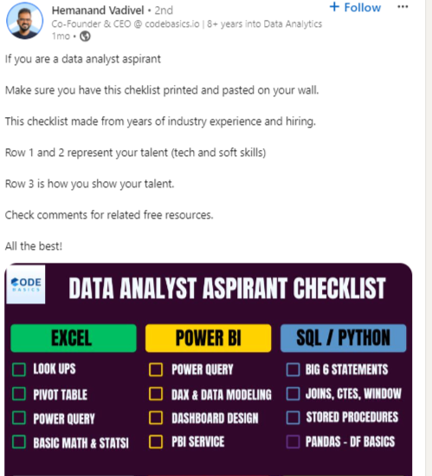
3. **Routine Building**  
     
   Share tips on how to create effective routines that boost productivity or well-being.  
     
   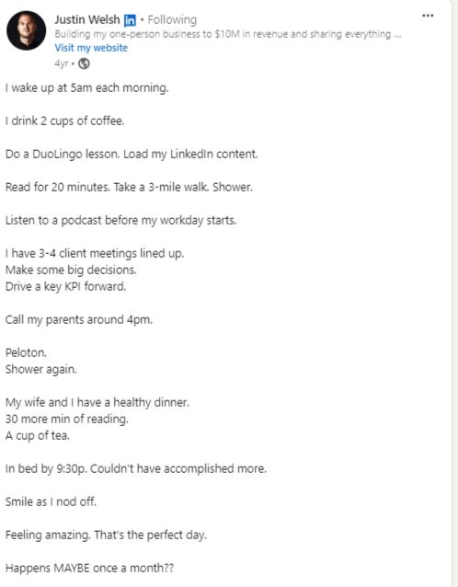
4. **Pictures with Clients**  
     
   Showcase photos with clients to build credibility and humanize your brand.  
     
   Accompany each photo with a brief story or testimonial that illustrates the positive impact of your work together.  
     
   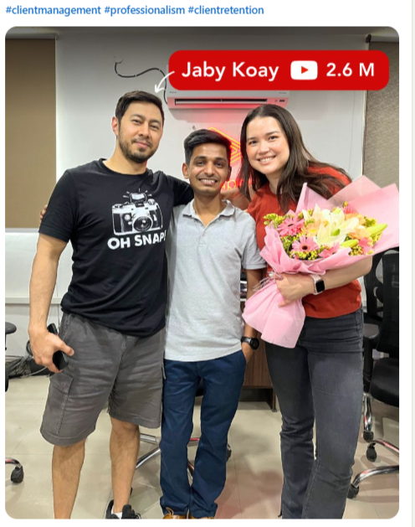
5. **Zoom Class Pictures**  
     
   Post snapshots from a Zoom class to show active engagement or expertise sharing.

This can also provide a sense of social credibility for your brand, letting people know you have an audience.  
  
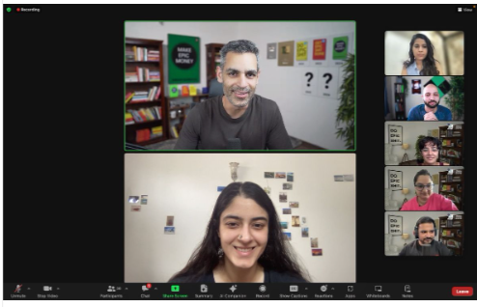

1. **Building Your Services**  
     
   Talk about how you’re developing or improving your services, showing transparency in the process.

People get to know that your brand is always moving forward.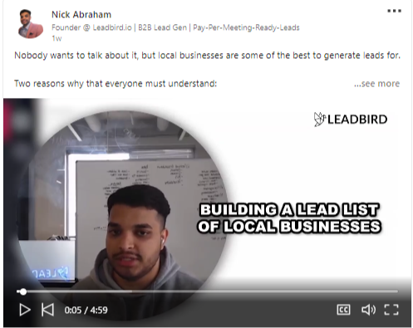

1. **Free lessons**  
     
   Share images from client training sessions to highlight your work and results.  
     
   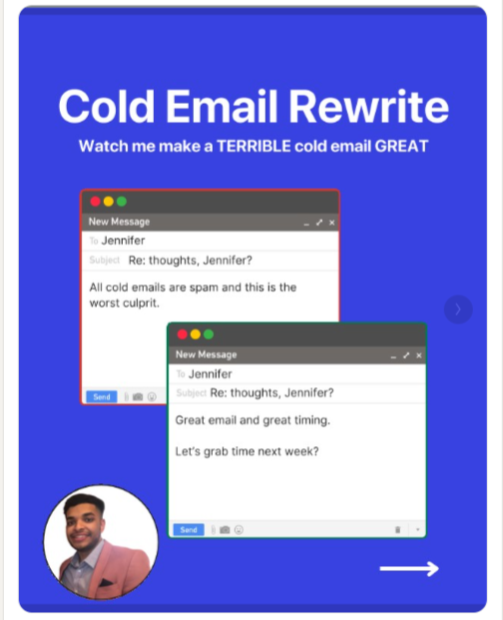
2. **Charts**  
     
   Present data visually using charts to make your points clearer and more impactful.  
     
   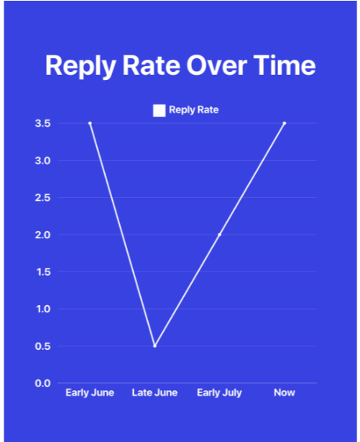
3. **Graphics**  
     
   Use visually appealing graphics to communicate ideas or summarize concepts.

It’s easier for people to learn from a graphic than a wall of text, AND it’ll look good 😉.

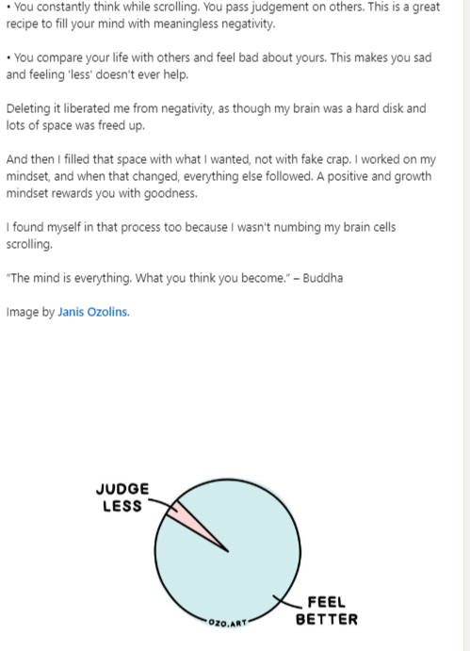

1. **Formulas**  
     
   Share useful formulas or equations relevant to your industry or expertise.

This builds some positive rapport with other people in your industry and may even reach new connections, making your network stronger.

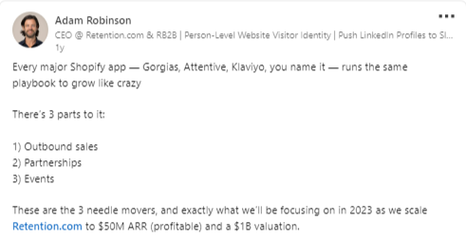

And that’s the end.   
  
Those are the highest-performing LinkedIn post ideas.

## Conclusion

**LinkedIn can help you find new customers!**

But just posting things won’t be enough.

You also need to reach out to people directly.

When your posts get popular, you can start real conversations with others.

Here’s what happens when your posts are popular:

* More people will look at [**your profile.**](https://www.salesrobot.co/blogs/linkedin-profile-tips)
* You will get **many likes and comments.**
* You might get **10-20 new followers** every day.

Some of these followers will ask you about your service.

But most people will just watch from far away.

These people want your service, but they don’t know you yet. They might be shy to message you first.

That’s why you should **reach out to them and start chatting**. This is how you can make money!

But don’t just send messages one by one. That can be hard and messy.  
  
You lose track of conversations quickly.  
  
Instead, use a LinkedIn and cold email automation tool like [SalesRobot](https://www.salesrobot.co/).

It can save you 80% of your time and[**lets you send personalized messages**](https://www.salesrobot.co/blogs/hyper-personalized-linkedin-outreach) effortlessly.

Here’s a quick example of what we’re talking about:

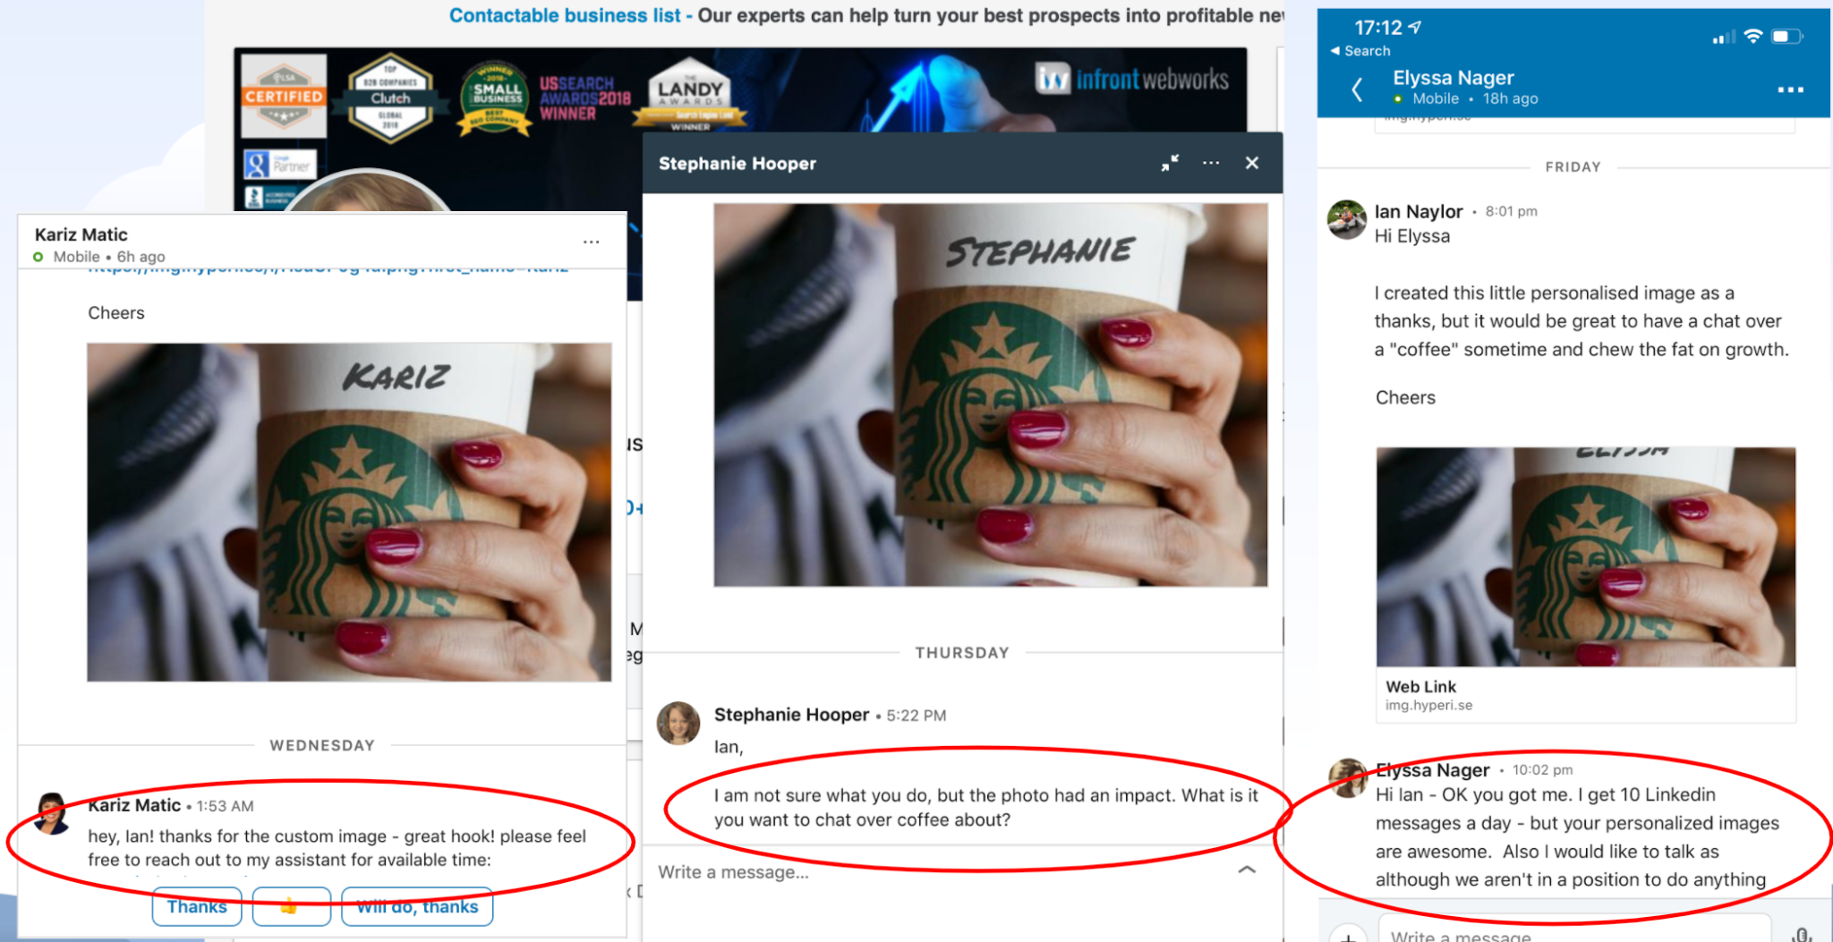

It’s not rocket science, you can easily do this too!

SalesRobot lets you create an outreach campaign with follow-ups and personalization to a list of prospects that match your ideal customer profile.

The best part? **It takes 5 minutes to set up.**

1. Login to SalesRobot and create a campaign

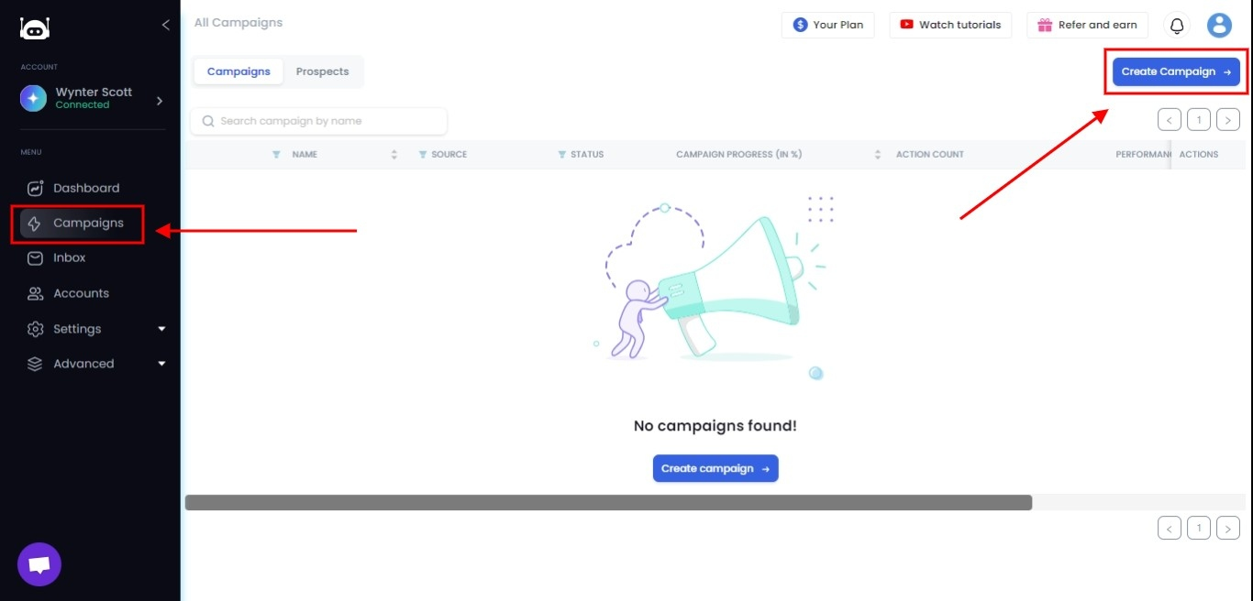

1. Select the SalesGPT option for a guided approach using our in-built AI.

## how to create SalesGPT campaign.

1. After describing your company, SalesGPT will generate a list of personas and their pain points for you to target

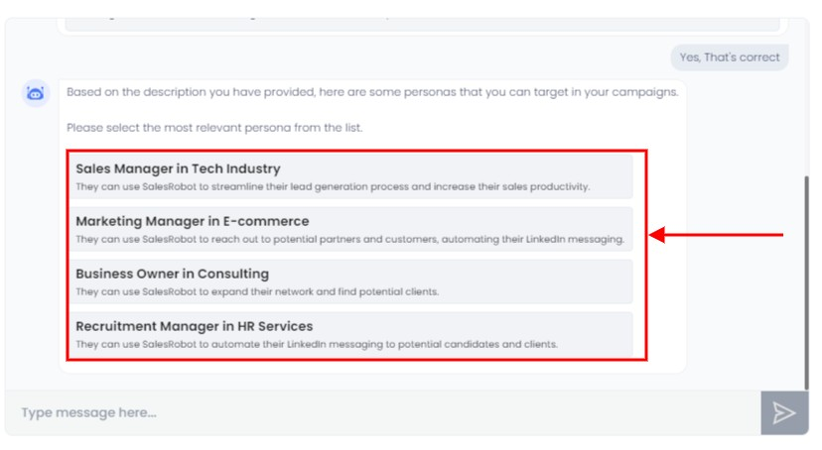

1. You can then set up a message sequence coupled with a connection request step, which you can customize as you wish.

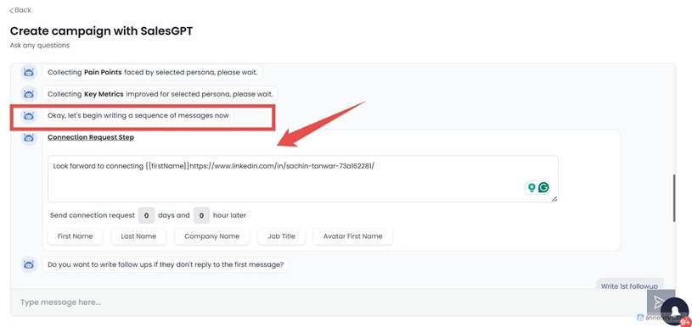

1. After setting up a message sequence along with follow-ups if they don’t respond, your next step is a list of prospects.

SalesRobot can get this through just a simple LinkedIn or Sales Nav search URL.

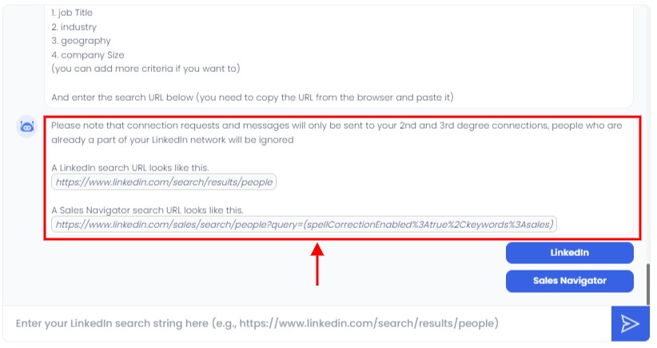

1. For example, just head to LinkedIn and search for your target audience using the available filters.

Then copy the URL, and paste it into SalesGPT.

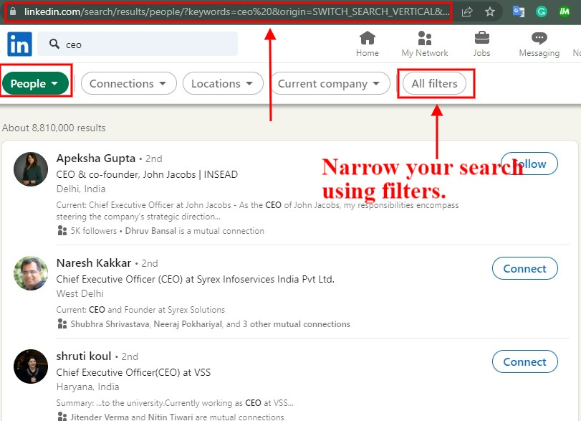

And that’s all there is to it!

You can just sit back and relax while SalesRobot sends out messages, follow-ups, connection requests, **even likes and posts on your feed!**

Every single LinkedIn action can be automated by SalesRobot even if your laptop isn’t on.

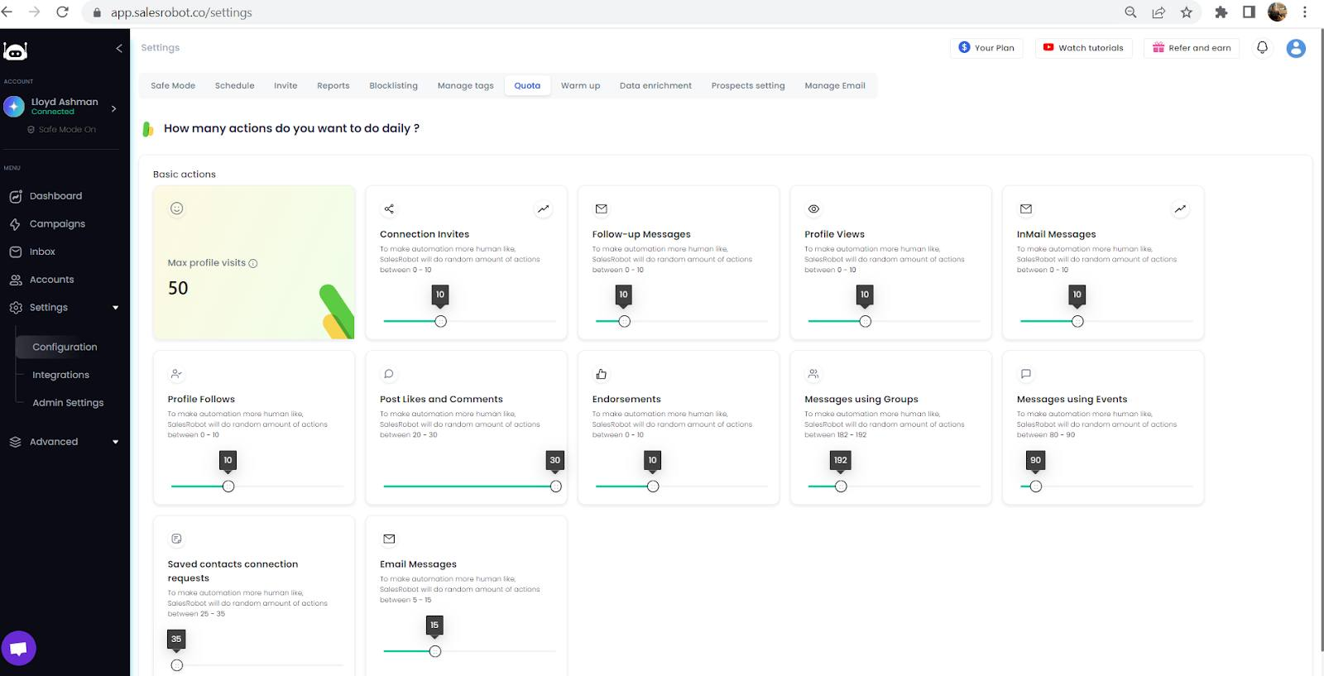

SalesRobot is cloud-based and has a **dedicated Safe mode** to keep your account secure, so you don’t even have to think twice.

Also, I have created a sequence that you can use.

<iframe width="540" height="305" src="https://3cd7b8fc.sibforms.com/serve/MUIFAOYKf8cdQyfj1tXv4jsZqdy5HWcX5qzQJm9Ckho0argqrCmuSjckyvdqoncs8EaHYZWSMbEpKY2sqox-fzE_xKdpNanxustUML5IU_55WluGjzpwMP5a1JZ2rAiPDnjrjlsSXLLYl6UrMI3ca_2stq3rOq-OPAnbtzavFCVcsqcCv2WFWJEWDaM_QY-5N16-0z_W6Y5nR-Bu" frameborder="0" scrolling="auto" allowfullscreen style="display: block;margin-left: auto;margin-right: auto;max-width: 100%;"></iframe>

Sounds interesting enough? Want to try it?   
  
Here’s a [**14-day free trial**](http://app.salesrobot.co/register) just for you. Try it and see how it transforms your LinkedIn inbound and outbound game.

(We don’t ask for credit card or phone numbers)

<Add a CTA>